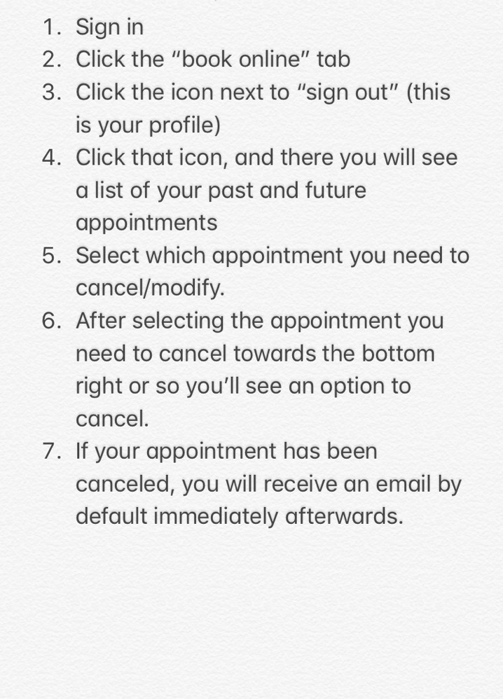
How to cancel/reschedule an appointment

